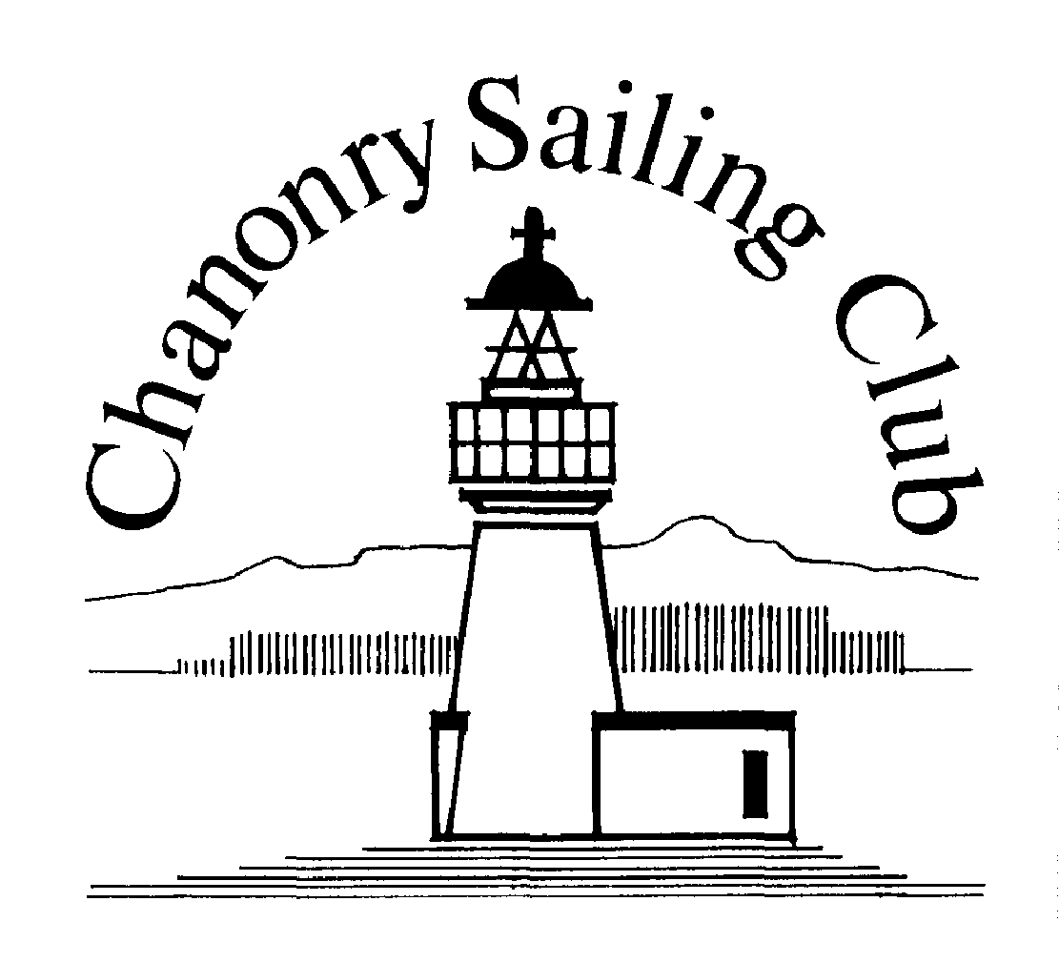
ENTRY FORM
BLACK ISLE CHALLENGE CUP
Saturday 14 September 2019
Chanonry Sailing Club, The Harbour, St. Andrew’s Walk, Fortrose, IV10 8TP
www.chanonry.org.uk

CLASS (The split between Fast and Slow Handicap will be 21.25 minutes/hour) - circle one
Fast handicap |  |  | Slow handicap
BOAT DETAILS
Vessel name: |  |  |  | Sail number:
Vessel class: |  |  |  | CYCA Rating or PY No. *:
Hull colour: |  |  |  | Spinnaker colour:
*If no PY or CYCA Handicap is available, please provide the following additional information so that handicap calculations can be made. Club handicaps can be used if supporting documentation is provided
Rig (e.g. sloop): |  |  | Spinnaker (Yes/No):
Engine (Outboard/Inboard): |  |  | Keel (e.g. Fin, bilge):
Propeller type (Inboard only): |  |  | Overall length:
CONTACT DETAILS
Club: |  |  |  | Names of all crew members (include DoB of any person <18):
Skipper name:
Skipper address:
Skipper mobile phone:

Skipper home phone:
Skipper email:
PRIVACY POLICY
CSC Privacy Policy is published at www.chanonry.org.uk/privacy-policy.html
We collect visitor’s name, address, telephone numbers, e-mail address, emergency contact details, boat details and relevant health information for the purposes of managing race entries and race results for Open events; sharing race results with other clubs, class associations, and the RYA; providing race results to local and national media; and contacting next of kin in the event of emergency.
DECLARATION  By completing and submitting this entry form Competitors involved are deemed to accept the rules under which the event is run and the disclaimer of liability below reproduced from the Notice of Race. |  |  | Disclaimer of Liability:  I understand that Competitors participate in the Event entirely at their own risk. See rule 4, Decision to Race. The organising authority will not accept any liability for material damage or personal injury or death sustained in conjunction with or prior to, during, or after the Event.
Please note any medical conditions, allergies, or dietary requirements that the organisers need to know of or “NONE”

Signature of skipper: Date:
Send completed form to: Sailing Secretary Chanonry Sailing Club, The Harbour, Fortrose, Ross-Shire, IV10 8TP e mail cgcampsie@gmail.com
Signed entry forms & the Entry Fee of £10 will be accepted on the race day. Please make cheques payable to Chanonry Sailing Club.

